**M.SC.I.T. GOVINDSAINI (07)**

VALIA C.I. COLLEGE OF COMMERCE & VALIA LC COLLEGEOFARTSCES ROAD D.N NAGAR

(Affiliated to University Of Mumbai)

**Mumbai-Maharashtra-400053**

DEPARTMENT OF INFORMATION TECHNOLOGY 

CERTIFICATE

This is to certify that the Journal entitled **Deep Learning** is bonafiedworkof **GOVIND SAINI** bearing Roll No: **07** submitted in partial fulfillment of therequirements for the award of degree of **BACHELOR OF SCIENCEinINFORMATION TECHNOLOGY** from University of Mumbai.

**Date: Internal Guide**

**M.SC.I.T. GOVINDSAINI (07) INDEX**

| **Sr.**  **No.** | **Practical** | **Pg. No.** |
| --- | --- | --- |
| **1** | **Write a Program to demonstrate following**  **operations.**  **i) Create Vector, Matrix and Tensor ii) Multiplication of two : Vector, Matrix andiii) Addition of two : Vector, Matrix and Tensoriv) Multiply Matrix with Vector v) Matrix Dot product and Matrix Inverse** | **1**  **Tensor** |
| **2** | **Performing matrix multiplication and finding Eigenvectors and Eigen values using TensorFlow** | **5** |
| **3** | **Solving XOR problem using deep feed forward** | **network. 8** |
| **4** | **Implementing deep neural network for performing**  **binary classification task.** | **12** |
| **5** | **A. Using deep feed forward network with twolayers for performing multiclass classificationpredicting the class.**  **B. Using a deep feed forward network with twolayers for performing classification and predictingprobability of class.**  **C. Using a deep feed forward network with twolayers for performing linear regression and predictingvalues.** | **16**  **hidden**  **and**  **hidden**  **the**  **hidden** |
| **6** | **A. Evaluating feed forward deep network for regressionusing K-Fold cross validation.**  **B. Evaluating feed forward deep network for multiclassClassification using K-Fold cross-validation.** | **29** |

**M.SC.I.T. GOVINDSAINI (07)**

| **7** | **Implementation of convolutional neural network**  **predict numbers from number images** | **to 37** |
| --- | --- | --- |
| **8** | **Demonstrate recurrent neural network that learnsperform sequence analysis for stock price.** | **to41** |
| **9** | **Performing encoding and decoding of images usingdeep Autoencoder.** | **48** |
| **10** | **Denoising of images using Autoencoder.** | **54** |

**M.SC.I.T. GOVINDSAINI (07)**

**PRACTICAL NO: 1**

**Aim : Write a Program to demonstrate following operations**

1) Create Vector, Matrix and Tensor

2) Multiplication of two : Vector, Matrix and Tensor 3) Addition of two : Vector, Matrix and Tensor 4) Multiply Matrix with Vector

5) Matrix Dot product and Matrix Inverse

**Code :**

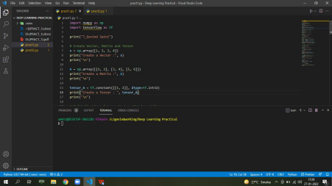1

**M.SC.I.T. GOVINDSAINI (07)** 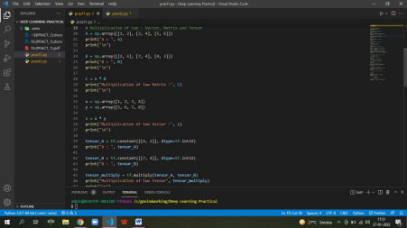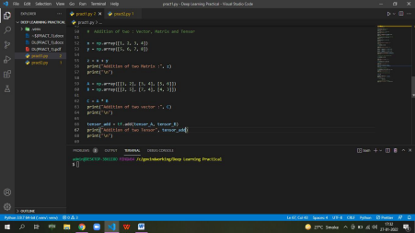

2

**M.SC.I.T. GOVINDSAINI (07) 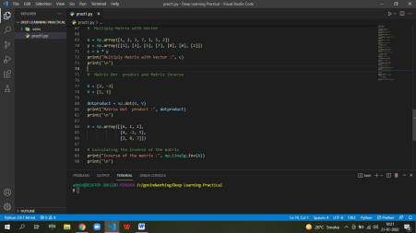Output :**

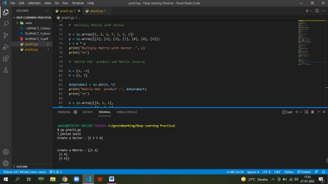3

**M.SC.I.T. GOVINDSAINI (07)** 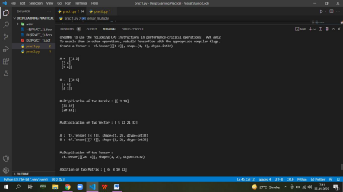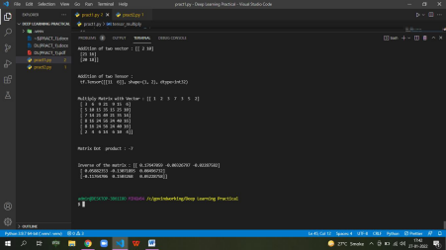

4

**M.SC.I.T. GOVINDSAINI (07)**

**Practical No : 2**

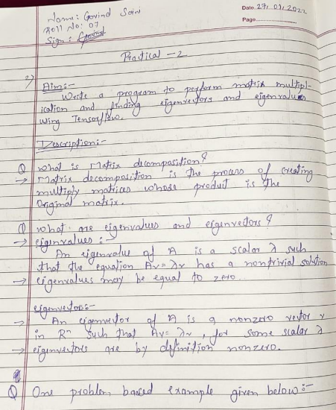**Code :**

5

**M.SC.I.T. GOVINDSAINI (07) 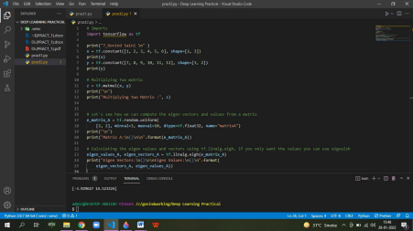Output :**

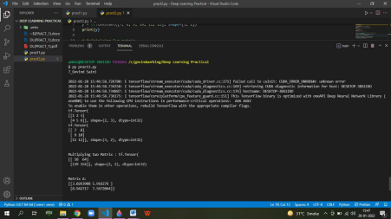6

**M.SC.I.T. GOVINDSAINI (07)** 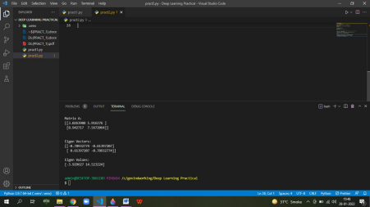

7

**M.SC.I.T. GOVINDSAINI (07)**

**Practical No : 3**

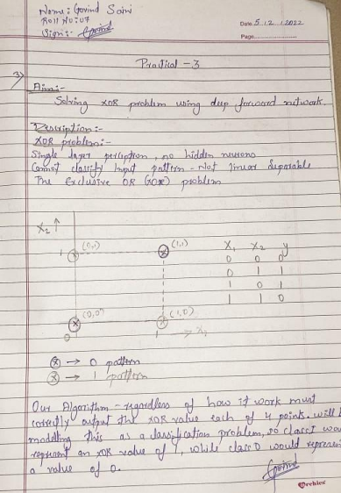8

**M.SC.I.T. GOVINDSAINI (07)** 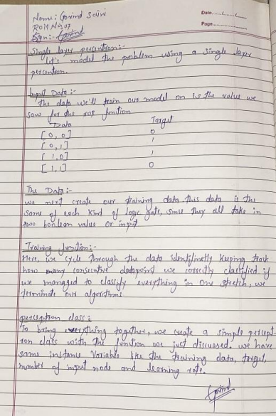

**Code :**

9

**M.SC.I.T. GOVINDSAINI (07)** 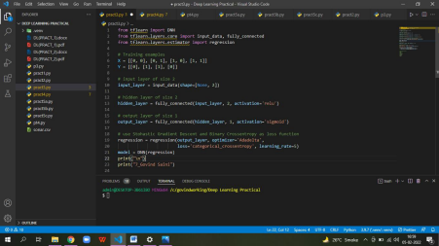

**Output**:

10

**M.SC.I.T. GOVINDSAINI (07) **

11

**M.SC.I.T. GOVINDSAINI (07)**

**Practical No : 4**

****12

**M.SC.I.T. GOVINDSAINI (07) **13

**M.SC.I.T. GOVINDSAINI (07) Code :**

****14

**M.SC.I.T. GOVINDSAINI (07) Output :**

****15

**M.SC.I.T. GOVINDSAINI (07)**

**Practical No : 5**

****16

**M.SC.I.T. GOVINDSAINI (07) **

**Code :**

17

**M.SC.I.T. GOVINDSAINI (07) **

**Output :**

18

**M.SC.I.T. GOVINDSAINI (07) **

19

**M.SC.I.T. GOVINDSAINI (07) **20

**M.SC.I.T. GOVINDSAINI (07) **21

**M.SC.I.T. GOVINDSAINI (07) **

**Code :**

22

**M.SC.I.T. GOVINDSAINI (07) **

23

**M.SC.I.T. GOVINDSAINI (07) Output :**

****24

**M.SC.I.T. GOVINDSAINI (07) **

25

**M.SC.I.T. GOVINDSAINI (07) **26

**M.SC.I.T. GOVINDSAINI (07) Code :**

****27

**M.SC.I.T. GOVINDSAINI (07) Output :**

****28

**M.SC.I.T. GOVINDSAINI (07)**

**Practical No : 6**

****29

**M.SC.I.T. GOVINDSAINI (07) **

**Code :**

30

**M.SC.I.T. GOVINDSAINI (07) **

**Output :**

31

**M.SC.I.T. GOVINDSAINI (07) (After changing neuron)**

****32

**M.SC.I.T. GOVINDSAINI (07) **33

**M.SC.I.T. GOVINDSAINI (07) **

**Code :**

34

**M.SC.I.T. GOVINDSAINI (07) **

**Output:**

35

**M.SC.I.T. GOVINDSAINI (07) **

36

**M.SC.I.T. GOVINDSAINI (07) Practical No: 7**

****37

**M.SC.I.T. GOVINDSAINI (07) **

**Code :**

****38

**M.SC.I.T. GOVINDSAINI (07) **

**Output :**

****39

**M.SC.I.T. GOVINDSAINI (07) **

40

**M.SC.I.T. GOVINDSAINI (07) Practical No : 8**

****41

**M.SC.I.T. GOVINDSAINI (07) **42

**M.SC.I.T. GOVINDSAINI (07) **

**Code :**

43

**M.SC.I.T. GOVINDSAINI (07) **

44

**M.SC.I.T. GOVINDSAINI (07) **

**Output :**

45

**M.SC.I.T. GOVINDSAINI (07) **

46

**M.SC.I.T. GOVINDSAINI (07) **

47

**M.SC.I.T. GOVINDSAINI (07)**

**Practical No : 9**

****48

**M.SC.I.T. GOVINDSAINI (07) **49

**M.SC.I.T. GOVINDSAINI (07) **

**Code :**

50

**M.SC.I.T. GOVINDSAINI (07) **

51

**M.SC.I.T. GOVINDSAINI (07) Ouput :**

****52

**M.SC.I.T. GOVINDSAINI (07) **

53

**M.SC.I.T. GOVINDSAINI (07) Practical No : 10**

****54

**M.SC.I.T. GOVINDSAINI (07) **55

**M.SC.I.T. GOVINDSAINI (07) **

**Code :**

56

**M.SC.I.T. GOVINDSAINI (07) **

57

**M.SC.I.T. GOVINDSAINI (07) Output :**

****58

**M.SC.I.T. GOVINDSAINI (07) **

59